Requirement Analysis
Solution Requirements (Functional & Non-functional)
Date | 04 September 2026
Student Name | Pulibanti Tejavani
Project Name | Metro Ticket Generating System
Maximum Marks

Functional Requirements
FR No. | Functional Requirement (Epic) | Sub Requirement
FR-1 | Application & Data Mode | Custom Metro application and Metro Station Details table.
FR-2 | Station Management | Store and manage available metro station names
FR-3 | Ticket Booking | Capture Starting From, Going To, Journey Type and Passenger Count
FR-4 | Fare Calculation | Automatically calculate fare based on route, journey type and passenger count
FR-5 | Payment Details | Provide payment mode selection and additional payment-mode input when required
FR-6 | Catalog Item | Book a Metro Ticket catalog item with configured variables
FR-7 | Portal Interface | Provide the ticket-booking experience through ServiceNow Service Portal
FR-8 | Client-side Automation | Dynamically populate fare values based on passenger and journey selections
FR-9 | QR Ticket Generation | Generate a digital QR code after ticket submission
FR-10 | Data Validation & Testing | Validate form behavior, ticket creation, fare calculation and QR generation

Non-functional Requirements
NFR | Requirement | Description
NFR-1 | Usability | Simple and guided ticket-booking interface
NFR-2 | Security | Restrict direct access to backend ticket data using ServiceNow access controls
NFR-3 | Reliability | Fare and field rules should behave consistently
NFR-4 | Performance | Ticket form and fare calculation should respond within normal ServiceNow interaction time
NFR-5 | Availability | System availability depends on the ServiceNow instance
NFR-6 | Scalability | Design should support future payment, notification and analytics enhancements
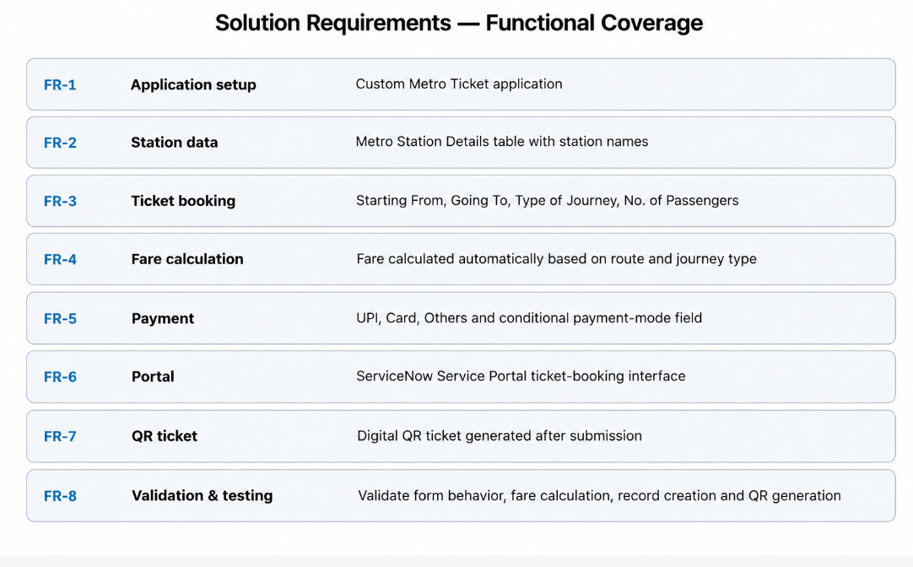
Figure 1: Functional requirement coverage.

